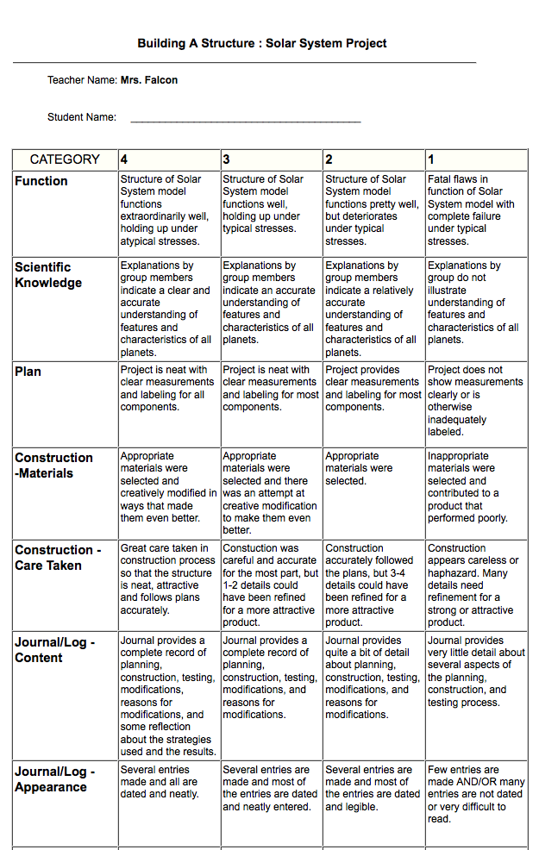

The Solar System project is a reflection of what you have studied and learned about our Solar System. You are invited to work with a partner for this project. You must contribute equally to the success of the project or you will loose credit. You will keep ongoing records in the form of a journal to support your work on this project. You will present your project in class.

The due date for this project is _________________________.

Students Name:_________________________________ Home Room Teacher:_____________________________________

You must include the following components for your solar system project:

Model: All planets, asteroid belt & the sun
Comparison of their size to each other and identification of inner or outer planets
Order and distance of the planets from the sun & each other

Unique physical features: color, tilt, rings (Saturn), and moon (Earth) should also be included when possible.

Labels identifying all parts of project

Journal: Typed, use 10-12 point font.
Include several dated entries with an explanation of the planning, building, modifying, reasons for modifying and result of building your model. Include a materials list and any limitations or struggles while building your solar system. Also include what you learned, what surprised you the most and what you enjoyed.
10 features and/or characteristics of each planet:
Examples can be found on your Planetary Summary Chart
(Tilt, rotation, gravity and temperature compared to earth, atmosphere, symbols, distance from the sun, composition, moons, rings, water, unique physical features, etc.

Presentation: Describe the build of your project; include things you are proud of and things that you struggled with. State two of the most interesting facts you found for each planet. Your presentation should take 5-7 minutes.

The following components are listed in a rubric on the back of this page:

Models Function 4 points______

Scientific Knowledge 4 points______

Projects plan 4 points______

Construction

Materials 4 points______

Care taken (it should be sturdy and not falling apart) 4 points______

Journal/content 4 points______

Journal/appearance 4 points______

*Participation - Cooperation with partner 7 points______

___________
Total Possible: 35 Points

*You and your partner will complete a survey about your participation in the project. Don’t let one person carry the load.

